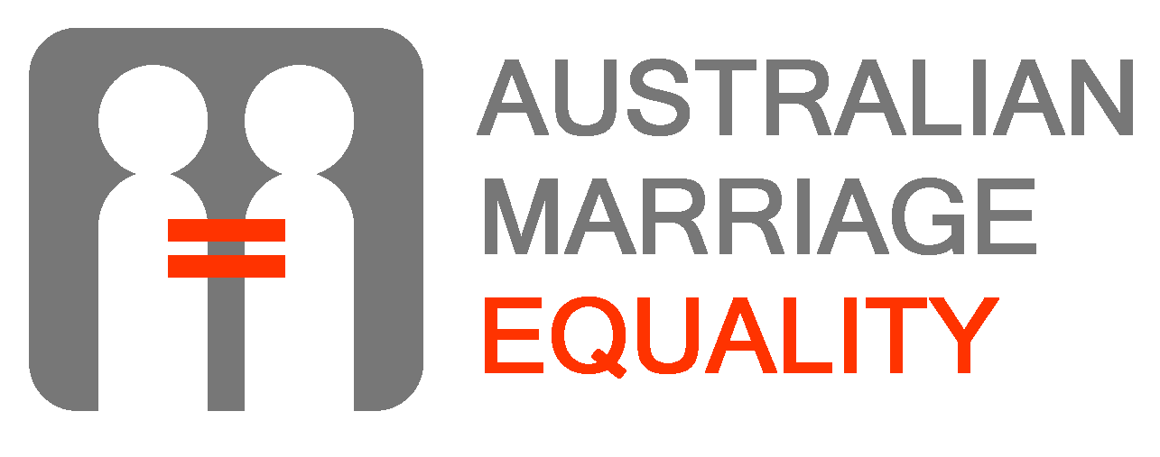

MEETING MPs: HANDY HINTS

The campaign for marriage equality is growing all the time. More and more Australians support full legal equality for same-sex couples. But equality will not be achieved until our politicians hear directly from those people who support reform, and particularly from those directly affected.

WHY VISIT MY LOCAL POLITICIAN?
Marriage equality is achievable but we’re not there yet. We need to convince federal politicians that marriage equality is an important and urgent issue. We also nee to counter the myths and misconceptions that surround the issue. Most of all our political leaders need to hear this is a real issue that affects real people. The most powerful thing you can do to help is to visit your local MP, and tell them your personal story and why changing the laws matters to you and your family.

TALK TO US ABOUT IT
When you decide to go, we can give you advice on where your MPs currently stands and how to get your message across. We can also put you in touch with others who have done the same thing. On top of this we run regular workshops to skill and empower people to advocate and lobby for equality. Please contact us for support, and to let us know how you went.
Email or call us when you’ve made your appointment and when you’ve been, so we can keep track. This is very important, as we want to make sure all MPs have met supporters of reform. Here are the best contacts:
Alex Greenwich, 0421 316 335, alex@australianmarriageequality.com
Rodney Croome, 0409 010 668, rodneycroome@australianmarriageequality.com

WE NEED LOTS OF HELP
We need everyone who supports marriage equality to help.
If you’re in a same-sex relationship, perhaps you could take your supportive parents or relatives to visit their local MP. This may result in a wider range of MPs being visited, and MPs may be more able to relate to them.
You could go with a partner or a friend to your own MP, or with others in your electorate who are affected. Don’t take too many people!
If you have children and are willing to take them, that’s great as it makes the issue more real. Otherwise you could take photos or tell everyday stories about them.
Whatever their political background, your MP and their staff will be polite, informal and professional with you, offering a cuppa and a biscuit.

BEING PREPARED
Make sure you know the name, party and, if possible, the stance of your local politician. Also make sure you have a basic grounding in the issues surrounding marriage equality, including the points made by opponents of reform. AME has a range of materials available on our website, from talking point sheets through to more comprehensive booklets and fact sheet.

TELLING YOUR STORY
Most important of all is that you tell your own story. Spend some time thinking about how your personal circumstances relate to the issue. For example, you may want to be married to feel more included in your own and your partner’s family. You may be married overseas and want your marriage recognised here. You may want to provide your children with legal security. You may have experienced discrimination and believe marriage equality will help remove stigma and stereotyping. It is your own personal story that will matter most when you are explaining why you support marriage equality.

FINDING YOUR FEDERAL MP
You have a lower house MP (Member of the House of Representatives, or MHR) and several upper house representatives (Senator). It is definitely worth visiting all of them.
- To find them ring the Australian Electoral Commission or the Australian Parliament House, or go online to www.aph.gov.au.
- Send a letter or email. All federal MPs have either an email addresses or an email webform which you can access through www.aph.gov.au
- You can also access your local MP through the Australian Marriage Equality site

REQUESTING A MEETING
- Request a meeting in your letter or email.
- Don’t suggest a date or time, they will get back to you. Do suggest preferred days/times if need be. Office hours are generally better, but after hours can be arranged.
- You should hear back within two weeks. If not, follow up by phone. Ask for the Electorate Officer, give the date of your original letter/email and re-iterate your request.

WHAT YOU COULD WRITE
- Date your letter and include your home address, even in an email, to show that you live in their electorate.
- State that you are requesting a meeting as their local constituent, representing your personal concerns. Tell them if you are coming alone or with other people.
- Briefly say what you want to discuss, eg “I would like the opportunity to discuss with you my support for allowing same-sex couples to marry.”
- Briefly describe how the issue affects you personally, e.g. “I live with my same-sex partner, but the law does not treat us the same as other loving couples.”

WHAT YOU MIGHT SAY
The meeting length will depend on how busy your MP is and how often they are in their electoral office. You will have 20-45 minutes, so be clear about what you want to say, and get to the point.
Focus on:
How the issue impact on you and your family personally.
- Introduce yourself and talk about your situation.
- Mention other couples and families you may know in the electorate (without mentioning names) to emphasise that there are others who are affected in their area.
- Ask if they are married, or intend one day to marry, and talk ask them what it feel like to be told they could not marry.
Why they must act.
- To explain the importance and urgency of the issue select some points from AME publications including our Talking Points sheet.
What you would like them to do.
- Whether they are a Government or Opposition MP, seek an undertaking that they will consider your views when they come to develop their own position, and when discussion occurs about their Party’s position.
- Conclude the meeting by asking “what undertakings can you provide to me about actions arising out of this meeting?” They should at least say that they will consider your views.
Let them know that their own/their Party’s position on the issue will directly affect whether you vote for them.

FREQUENTLY ASKED QUESTIONS
Is it worth visiting my local MP if they are not a member of the Government party?
- YES! Particularly if your electorate is marginal seat that changes hands regularly. It’s important for Liberal/National MPs to know the level of support for marriage equality in their electorate. When it comes to discussion in the party room/caucus, if MPs have only heard from anti-equality constituents, they are likely to say that this is their position as reflected by the majority of their constituents.
What can a local MP do?
- They can raise your concern with the their party caucus and national leaders.
- A local MP should reflect the general consensus of their constituents, hence the importance of lobbying both Government and Opposition MPs.
Can’t I just write a letter?
- Writing letters to your local MP are a good addition to personal lobbying, but it is not nearly as effective. If letters alone are to get attention, they need to not be form letters, and they need to arrive in large numbers. You could organise you family, workplace or club to write letters, perhaps together.

YOUR VISIT CHECKLIST
❏ Read this sheet
❏ Download and read info from AME’s website
❏ Find your MPs online
❏ Made an appointment.
❏ Emailed ame@australianmarriageequality.com to tell us you’ve made the appointment.
❏ Visit your MP and don’t forget to tell us all about it!
❏ Encourage five friends/family members to do the same, and/or go with them.

“The received wisdom is that if a Minister/MP is sent one letter on an issue, staff reply; if they get ten, the Minister notices it; if twenty arrive, s/he gets advice; and if the staff receives forty, s/he acts ... The same goes for letters to the editor. If there are one or two, they are of interest. If there are ten, the issue is checked out. If there are more than twenty, the papers know there is an issue and maybe a campaign. Editors are cynical beasts: if the letters are exactly the same or look like a form letter, they disregard them.”
– Kirner, J, and Rayner, M, The Women’s Power Handbook, p. 271

Visit www.australianmarriageequality.com or contact us via:
Alex Greenwich, 0421 316 335, alex@australianmarriageequality.com
Rodney Croome, 0409 010 668, rodneycroome@australianmarriageequality.com

