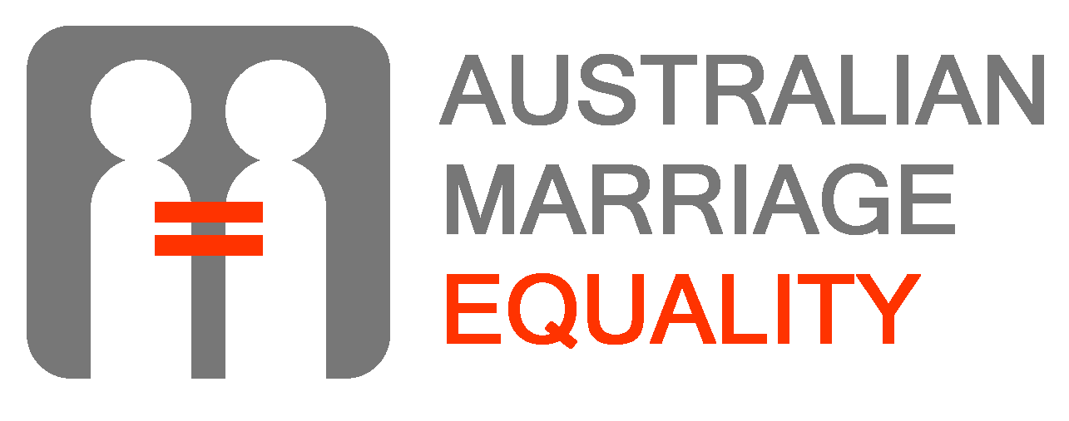

MARRIAGE EQUALITY: TALKING POINTS

WHAT IS MARRIAGE EQUALITY?
- The Marriage Act explicitly rules out marriages between partners of the same sex. It also says overseas same-sex marriages will not be recognised by the Australian Government.
- Marriage equality means amending the Marriage Act so same-sex partners can marry in exactly the same way as opposite-sex partners.

WHY DO WE WANT MARRIAGE EQUALITY?
- Same-sex partners are not equal under the law.
- The law sends out the message that it is okay to discriminate on the grounds of sexual orientation and gender.
- The law sends out the message that same-sex partners are not capable of the level of love and commitment associated with marriage.
- Marriage creates a unique bond between partners and their families from which same-sex partners are excluded.
- Exclusion from such an important institution as marriage re-inforces stigma against same-sex relationships which has negative impacts on health and well-being of all gay, lesbian, bisexual and transgender people.
- Same-sex partners shouldn’t be forced overseas to marry and denied recognition of their solemn vows when they return.
- Marriage will benefit from being seen as less discriminatory and more relevant.

WHO SUPPORTS MARRIAGE EQUALITY?
- Polls show between 57% and 62% of Australians support marriage equality.
- Surveys show 80% of same-sex partners support the right to marry and 55% would marry if they could.
- Marriage equality has the support of many prominent Australian people and organisations including former Governor-General, Bill Hayden, former Chief Justice of the Family Court, Alastair Nicholson, Queensland Premier, Anna Bligh, singer Rob Mills, comedian Wil Anderson, the Commonwealth Bank, QANTAS and Telstra. The Bureau of Statistics has agreed to count same-sex couples married overseas in the next Census.

SAME-SEX COUPLES HAVE EQUAL RECOGNITION IN AREAS LIKE TAXATION AND WILLS. ISN’T THIS ENOUGH?
- Same-sex partners can legally be considered de facto partners. But to qualify they have to jump through hoops like living together for a certain period. They may have to prove they are de facto partners by producing evidence of a shared life. De facto entitlements differ between the states and are not recognised overseas
- The difficulties proving de facto status are a particular problem in emergency situation where quick decisions must be made by a same-sex spouse.
- A marriage certificate gives instant and guaranteed access to relationship entitlements. It is also much more widely recognised and respected than de facto status.

WHY CALL IT A MARRIAGE? WHY NOT HAVE A CIVIL UNION?
- Civil unions are not as widely understood or respected as marriages.
- Creating a separate name for same-sex relationships entrenches a different, discriminatory, second-class status for these relationships.
- We already have civil unions in most states so why replicate this at a national level?
- No-one writes love songs about civil unions.

WHAT ABOUT RESPECTING THE RELIGIOUS ORIGINS AND CONNOTATIONS OF MARRIAGE?
- Marriage existed long before today’s major religions came into being, for example early Christians married under Roman civil law.
- In our society marriage is governed by civil law and not by biblical values, for example we allow marriage between people of different faiths or no faith. We also allow divorce although some churches are against it. Using the religion argument against same-sex couples is a double-standard.
- Some Christian churches currently solemnise same-sex marriages and are discriminated against because the Government doesn’t recognise these marriages in the same way it recognises the opposite-sex marriages performed in other churches.
- Religious celebrants are free to refuse to marry couples whose relationship they don’t agree with and this freedom will remain when marriage equality is achieved.

WHAT ABOUT THE CHILDREN?
- The law does not say married opposite-sex couples must have children. This is why we allow infertile couples to marry. Using the infertility argument against same-sex couples is a double-standard.
- As many as 25% of same-sex couples are raising children. By allowing parents in these families the right to marry we are providing their children with the same rights, respect and recognition as other children.
- The Australian Psychological Society has found that children raised by same-sex couples are just as well adjusted, psychologically, sexually, intellectually and socially as their peers.

WILL MARRIAGE EQUALITY CHANGE MARRIAGE?
- It will remove discrimination from marriage in the same way discrimination was removed when interracial couples were allowed to marry in the 1960s.
- The rules governing marriage have changed many times, for example, wives are no longer treated as the property of their husbands, we prohibit rape in marriage, and we allow divorce.
- But the basic definition of marriage as a lifelong commitment between a loving couple has not changed and will not change.

WILL MARRIAGE EQUALITY DEMEAN OR DESTROY MARRIAGE?
- In countries which allow same-sex couples to marry, marriage still exists, no opposite-sex marriages have been harmed, and the rates of younger heterosexual people marrying has actually increased.
- Someone who thinks their own marriage is threatened by same-sex marriages must not have a very strong marriage.

IS THERE A SLIPPERY SLOPE TO RECOGNISING OTHER RELATIONSHIPS?
- Incestuous and polygamous relationships have not been legitimised in any of the many countries that allow same-sex couples to marry.
- Relationships between people and animals or inanimate objects have also not been considered “marriages” because marriage is a legal contract and dogs and cars can’t sign contracts.

WILL MARRIAGE EQUALITY COST MONEY?
- Same-sex couples already have entitlements in areas like tax and social security so marriage equality will make little difference to government income and expenditure in these areas.
- Where it will make a difference is by injecting many millions of dollars into the economy through wedding expenditure and into government revenues through marriage license fees.

THE BENEFITS OF MARRIAGE?
- Many opponents of marriage equality believe marriage has benefits for married partners including better health and longer life, and that children of married partners are better adjusted.
- If this is true, same-sex partners and their children should be able to share these benefits too.
- Some opponents believe gays and lesbians should not be allowed to marry because our relationships are too unstable, superficial and short.
- This is not true. But if it is, surely allowing gays and lesbians to marry would be a solution?

WHY DON’T WE CALL IT “GAY MARRIAGE”?
- “Gay marriage” suggests a different kind of marriage, and marriage equality is about ensuring all couples have access to the one legal institution known as “marriage”.

“I JUST DON’T LIKE IT!”
- If you don’t like same-sex marriages, don’t have one.

